Individual Placement and Support(IPS) Supported
Employment
Evidence Based Practices

Disclaimer: Please note that this document is subject to updates and revision. The information is accurate as of the following date: September 08, 2026. Providers should reference the OPOH and the Optum website for the most updated materials.

Overview of IPS Services

The IPS model of Supported Employment is an EBP designed to support individuals living with behavioral health needs in obtaining and sustaining competitive employment in the community to support their recovery.

IPS has been shown to be effective among a wide range of individuals living with mental health conditions, Substance Use Disorders (SUDs), and co-occurring mental health conditions.

IPS is a person-centered intervention that emphasizes a client’s strengths, goals, and preferences. A team of employment specialists collaborates with each client to help them in their initial job search and with ongoing follow-along supports once they secure employment.

Within the Specialty Mental Health system, IPS can supplement a wide range of clinical behavioral health interventions, including but not limited to ACT, FACT, CSC, and other intensive outpatient services.

The evidence-based IPS model is characterized by the following principles:

- Competitive, integrated employment- Clients are supported to seek and retain competitive jobs in the community with market wages and no artificial time limits.

- Systematic job development- IPS teams proactively visit employers of interest to clients to learn about their business needs and hiring preferences

- Rapid job search- Searching for a job begins quickly and is not delayed by assessment or training.

- Integrated services- IPS activities are integrated with mental health care.

- Benefits planning- Clear, personalized information is provided to clients about the interaction of employment with their benefits, so clients are not negatively impacted by employment.

- Zero exclusion- No job seeker with a behavioral health condition that desires competitive employment is excluded.

- Time-unlimited supports- Individualized support continues as long as the client wants and needs them.

- Worker preferences- Services and jobs sought are based on each client’s preferences and choices rather than the judgment of the IPS team.

IPS Supported Employment does not include:
- Generalized employer contacts that are not connected to a specific enrolled individual or an authorized service

- Services for individuals in sub-minimum wage, or sheltered workshop settings

- Facility-based habilitation or personal care services

- Wage or wage enhancements for individuals

- Duplicative services from other state or federal programs

- Payment to employers for supervision, training, support, and adaptations typically available to other workers without disabilities filling similar positions in the business

Supported Employment Settings: IPS Supported Employment is provided in a community-based setting, including an outpatient behavioral health setting or a community location. At the individual’s request, an IPS Supported Employment provider may provide services in the individual’s home or deliver services via telehealth. IPS Supported Employment services may not be delivered in provider-operated or controlled residential settings. Employment gained as a result of IPS Supported Employment services will be in a competitive employment setting.

(SPA 24-0051)

Criteria for Services

Target Population
- Adults, ages eighteen (18) and older, who have a serious mental illness (SMI) and are interested in becoming competitively employed.
- Factors such as individual presentation, behavioral health symptoms, job readiness, or treatment engagement have no impact on the medical necessity for the service.

Components of Services

The evidence-based model includes a specific set of pre-employment services (e.g., job-related assessment) and employment sustaining services (e.g., ongoing job coaching and follow-along supports).

Person-Centered Planning Process: All individuals receiving IPS Supported Employment participate in a person-centered employment planning process. IPS Supported Employment is fully voluntary
In the person-centered planning process, the IPS Supported Employment team works with the individual to:
- Identify the individual’s strengths, preferences and goals

- Determine the desired outcome of IPS Supported Employment services

- Identify other members of the individual’s mental health treatment team and significant support network; and

- Review other preferences and cultural considerations to inform the delivery of IPS Supported Employment.

Career Profile: The information gathered through the person-centered employment planning process is captured in a career profile. Both the IPS Supported Employment team and the individual must sign off on the career profile. Career Profile templates and tip sheets can be found in the IPS Employment Center Resource Library
The person-centered employment planning process is complemented by updates made to the individual’s clinical record on an ongoing basis by a behavioral health practitioner in consultation with the individual. The state assures that the planning process:
- Is timely and occurs at times and locations convenient to the individual

- Reflects the individual’s cultural considerations and is conducted by providing information in plain language and in a manner that is accessible to individuals with disabilities and persons who are limited in English proficient

- Includes strategies for solving conflict or disagreement within the process

- Includes a method for the individual to request updates to the plan, as needed.

Additionally, the state assures that the plan:
- Reflects the individual’s strengths and preferences

- Reflects clinical and support needs as identified through an assessment of functional need

- Includes individually identified goals and desired outcomes

- Reflects the supports (paid and unpaid) that will assist the individual to achieve identified goals, and the providers of supported employment, including natural supports

- Reflects risk factors and measures in place to minimize them, including individualized backup plans and strategies when needed

- Be understandable to the individual and the individuals supporting them

- Identifies the individual and/or entity responsible for monitoring the plan

- Be finalized and agreed to, with the informed consent of the individual in writing, and signed by all the individuals responsible for its implementation

- Be distributed to the individual and other people involved in the plan

- Prevents the provision of unnecessary or inappropriate supports

Medical Necessity
(Definition CalMHSA Doc Guide- pg. 7)

A person qualifies for Specialty Mental Health Services (SMHS) if they have a mental health condition (or are at risk of developing one) and the condition causes problems in important areas of life such as work, school, family relationships, daily functioning, housing stability, or personal safety. Once a person qualifies for SMHS, the provider must determine whether IPS services are reasonable and necessary for that particular client.

Employment is not the treatment by itself. Instead, employment is used as a tool to support a person's mental health recovery.

Simply helping someone find a job is not medically necessary. Helping someone overcome mental health barriers that prevent them from getting or keeping a job is.

Every service should clearly connect the employment support provided to the client’s mental health recovery, improved functioning, or symptom management. A simpler way to think about it can be to ask yourself: "How is what I'm doing today helping this person's mental health or functioning?"

Documentation should demonstrate the relationship between the member's behavioral-health needs and the service being provided.

Not Medically Necessary:

A job seeker asks you to:
- Update their resume because they don't like the formatting.
- Print job applications.
- Drive them to an interview because it's convenient.
- Search Indeed for job openings without discussing any mental health barriers.

These activities alone are employment services—but they are not Specialty Mental Health Services.
Medical Necessity:

Example 1: A job seeker experiences severe anxiety whenever they attend interviews.

The IPS Specialist:
- Helps the client identify anxiety triggers.
- Practices interview skills to reduce anxiety.
- Uses grounding techniques before interviews.
- Helps the client develop coping strategies if anxiety increases during the interview.

Example 2: A job seeker has depression and has stopped applying for jobs because they believe they will fail.

The IPS Specialist:
- Uses motivational interviewing.
- Breaks tasks into manageable steps.
- Reinforces previous successes.
- Encourages participation despite depressive symptoms.

The intervention addresses the depression that is interfering with employment.

Bottom Line: The focus is treating the mental health barrier, not simply getting a job.

Medical necessity exists when the mental health condition is affecting the client’s ability to:

Obtain employment | Maintain employment | Attend interviews
Participate in education | Complete job searches | Interact with supervisors or coworkers
Manage workplace stress | Maintain attendance | Follow through with work responsibilities

Medical Necessity Criteria (BHIN 26-002)

Access Criteria for Clients Age Twenty- One (21) or Older

Must meet both of the following (1 and 2):

- One (1) or both of the following:

  - Significant impairment (i.e. distress, disability, or dysfunction in social, occupational, or other important activities). AND/OR

  - A reasonable probability of significant deterioration in an important area of life functioning.

- The client’s condition is due to either of the following:

  - A diagnosed mental health disorder OR

  - A suspected mental health disorder

Access Criteria for Clients Under Age Twenty- One (21)

Must meet either of the following (1 or 2):

- Scoring in the high-risk range under a trauma screening tool approved by the department, involvement in the child welfare system, juvenile justice involvement, or experiencing homelessness. OR

- The client meets both of the following requirements in a and b:

a. The client has at least one (1) of the following:

- A significant impairment.

- A reasonable probability of significant deterioration in an important area of life functioning.

- A reasonable probability of not progressing developmentally as appropriate.

- A need for SMHS, regardless of presence of impairment, that are not included within the mental health benefits that a Medi-Cal Managed Care Plan (MCP) is required to provide.

AND

b. The client’s condition as described in 2 above is due to one (1) of the following:

- A diagnosed mental health disorder, according to the criteria of the current editions of the DSM and the ICD.

- A suspected mental health disorder that has not yet been diagnosed.

- Significant trauma placing the client at risk of a future mental health condition, based on the assessment of a licensed mental health professional.

IPS Team & Staffing

The need for IPS Supported Employment services is determined by or under the direction of a mental health professional or licensed practitioner of the healing arts defined in Supplement 3 to Attachment 3.1-A through a person-centered planning process and is documented in the individual’s clinical record. (SPA) 24-0051

Providers of IPS Supported Employment services must all complete training in the evidence-based model of IPS Supported Employment.

IPS is a team-based service. IPS teams are typically composed of two (2) employment specialists and an employment supervisor who supports up to five (5) IPS teams. A typical IPS team will support a caseload of thirty-five (35) to forty (40) clients.

Employment Specialists

- Any Medi-Cal behavioral health practitioner may be trained in the IPS model to serve as an employment specialist

- No additional certification is required to serve as an employment specialist.

- An employment specialist may also have:

  - Experience in employment services, including job development, employment counseling, or vocational rehabilitation;

  - An educational background in social work, psychology, vocational rehabilitation, or a related field; and/or

  - Experience in client-centered service delivery and case management, including experience managing a caseload, coordinating with other service providers, helping clients address barriers to employment, and cultural competency.

Employment Supervisors

- One (1) employment supervisor will typically support up to five (5) IPS teams.
While IPS providers are not required to have an LPHA on staff , the California Medicaid State Plan requires that SMHS, including ACT, FACT, CSC, IPS Supported Employment, and Clubhouse Services, be provided by or under the direction of one of the following mental health providers functioning within the scope of their professional license and applicable state law: a physician; a licensed or waivered psychologist; a licensed, waivered or registered social worker; a licensed, waivered or registered marriage and family therapist; a licensed, waivered or registered professional clinical counselor; a registered nurse (including a certified nurse specialist, or a nurse practitioner); or a licensed occupational therapist.

Head of Service: DEFINITIONS OF HEAD OF SERVICE PER CALIFORNIA CODE OF REGULATIONS, TITLE 9

Definitions of Credentials:

- LPHA: Licensed Practitioner of the Healing Arts: Physician, Nurse Practitioner (NP), Physician Assistant (PA), Registered Nurse, Registered Pharmacist, Licensed Clinical Psychologist (LCP), Licensed Clinical Social Worker (LCSW), Registered CSW, Licensed Professional Clinical Counselor (LPCC), Registered PCC, Licensed Marriage and Family Therapist (LMFT), Registered MFT, Licensed Vocational Nurse (LVN), Licensed Occupational Therapist (LOT), and Licensed Psychiatric Technician (LPT)

- Scope of practice refers to those activities that a person licensed to practice as a health professional is permitted to perform, which is increasingly determined by statutes enacted by state legislatures and by rules adopted by the licensing entity. Please utilize the link/table to determine services within scope of practice for different staff: Scope of Practice (CALMHSA Documentation Guide- Appendix III (pg. 39)

- Waivered: a person who was hired from outside California, whose experience is sufficient to gain admission to the appropriate licensing examination and who has been granted a professional licensing waiver approved by the Department of Health Care Services to the extent authorized under state law.

EBP Components of Programming

The evidence-based model includes a specific set of pre-employment services (e.g., job-related assessment) and employment sustaining services (e.g., ongoing job coaching and follow-along supports).

IPS Service Components
Pre-Employment Services | Employment Sustaining Services
Job-related discovery or assessment | Career advancement services
Person-centered employment planning | Negotiation with employers
Job development and placement | Job analysis
Job carving | Job coaching
Benefits education and planning | Benefits education and planning
 | Asset development
 | Follow-along supports

Definitions:

- Pre-Employment Services- Pre-employment services support a client in attaining a competitive job to support their individualized recovery. In most cases, a client will meet with their IPS team at least weekly during the pre-employment stage of IPS.

Pre-employment services include:

  - Job-related discovery or assessment- The IPS team works with the client on an ongoing basis to understand their work experience, job skills and goals, and to identify jobs for the client.

  - Person-centered employment planning- The IPS team and the client work together to develop a “career profile” that outlines the client’s individual strengths, preferences and goals, desired outcomes of IPS, and cultural considerations to support their job search and placement.

  - Job development and placement- The client works with the IPS team to identify and secure work that aligns with the client’s strengths, preferences, and recovery goals.

  - Job carving- The IPS team engages directly with employers to develop, modify, or customize a specific role that would be appropriate for the client.

  - Benefits education and planning- The client receives benefits counseling to understand how work may affect their benefits (e.g., Medi-Cal coverage or Social Security income) and guide their plan for starting work.

- Employment Sustaining Services- Once a client secures competitive employment, the IPS team provides ongoing coaching and follow-along supports to address challenges in the workplace and support the client in achieving their recovery goals. Clients typically receive employment sustaining services weekly during the initial months of employment, followed by ongoing coaching and other supports on a less frequent cadence. In most cases, follow along supports are provided for six (6) months or more after a client secures a job, with the exact duration tailored to the client’s ongoing needs and preferences.

Job sustaining services include:

  - Career advancement services- The client works with the IPS team to identify opportunities for promotion or advancement in their role, or to identify new opportunities when appropriate.

  - Negotiation with employers- The IPS team engages directly with employers to adjust or restructure the client’s job or to discuss accommodations on an ongoing basis.

  - Job analysis- The IPS team and the client review tasks required as part of the client’s job and identify skills or training that may be required to succeed in that role, such as managing social challenges at work, and managing symptoms or medication side effects on the job.

  - Job coaching- The IPS team works with the client to support them in addressing challenges in the workplace and developing skills to strengthen their performance at work.

  - Benefits education and planning- Once a client is working, the IPS team helps the client manage their benefits on an ongoing basis as they increase their earnings.

  - Asset development- The IPS team supports the client in understanding and managing the earnings from their job

  - Follow-along supports- The IPS team engages with the client on an ongoing basis to support them in the workplace.

Care Coordination

While providing pre-employment and employment sustaining services is the primary responsibility of IPS teams, IPS teams should also be available to support clients in connecting to healthcare and other services within the community.

Employment specialists and employment supervisors should be knowledgeable about, and have relationships with, a wide range of community supports available to clients as applicable to securing or maintaining employment.

Employment specialists should facilitate referrals, warm handoffs and other linkage activities for clients as needed, such as:

- Physical health care services
- Housing supports
- ECM providers
- Substance use treatment
- Emergency services
- Social services
- Self-help/peer-run services
- Independent living centers
- Clubhouses
- Natural community supports

IPS should be coordinated with other services and supports to ensure clients receive comprehensive behavioral health treatment.

ACT/FACT

- If the client’s needs exceed the employment/education supports that the program can provide, then they are to refer to IPS for IPS Supported Employment Services. When IPS and ACT are delivered separately, an IPS team member should regularly participate in ACT team meetings to support care coordination for that client.

- In addition, there should be regular communication across IPS teams and ACT teams operating in a county to ensure clients have access to both evidence-based services delivered with fidelity, while ensuring services are not duplicated across programs.

CSC

- If the client’s needs exceed the employment/education supports that the program can provide, then they are to refer to IPS for IPS Supported Employment Services. When IPS and CSC are delivered separately, an IPS team member should regularly participate in CSC team meetings to support care coordination for that client.

- In addition, there should be regular communication across the IPS and CSC teams in a county to ensure services are coordinated and not duplicated.

Required Posted Brochures & Notices

Please use the Behavioral Health Plan Informing Material to request hard copies of brochures and posters related to the Member Grievance and Appeal Processes as well as other Member Materials. Electronic versions of all materials are available to print on the Optum Website> Beneficiary tab.

The order form also includes information on where to access grievance and appeal forms and how to request required postage paid envelopes for clients to mail grievances and appeals. To receive the materials in the audio or large print format contact QIMatters.HHSA@sdcounty.ca.gov, or providers may duplicate their own copies.

All of the following brochures and notices must be clearly displayed in all available threshold languages:

- Behavioral Health Plan (BHP) Member Handbook

- Current Provider Lists with instructions for accessing in all languages

- Current Limited English Proficiency Posters

- Current Notice of Privacy Practices

- Current Problem Resolution Process brochures (locatable without requiring
the client to request from staff)

- Current Problem Resolution Process posters (with fair hearing process)

- Current grievance/appeal forms with self-addressed, stamped envelopes
available (without requiring a client to request them from staff)

- Open Payments Database Notice- included on provider/legal entity’s website (if
applicable).

- Physician Notice to Patients from the Medical Board of California (with QR Code)

- California Board of Psychology Consumer Statement

- BBS Notice Display of License/Registration Notice to Consumers (SB 1024)

- BBS Notice- Updated Requirement to Provide Notice to Psychotherapy Clients (Notice to Clients- AB 630)

- Human Trafficking Model Notice (For facilities that provide pediatric care

Required Processes & Documentation

All IPS Supported Employment teams must abide by all Medi-Cal documentation requirements for SMHS as described in BHIN 23- 068.

Process | Who Can Provide | Resources
Service Verification/ Program Integrity  Not in SmartCare- Typically outlined in program contract | Any staff | OPOH Section G
TADT  (MH Non-Psychiatric SMHS Timeliness Record) | Any staff can collect the information but it must be entered in SmartCare by staff with access. | MH Access Times Tip Sheet  How to Document Timely Access Record Information for TADT - 2023 CalMHSA
NOABD Logs  Not in SmartCare | Any staff | OPOH Section C  NOABD Tip Sheet  Optum Website > NOABD tab
CSI Standalone Collection  (CSI Standalone Collection) | Any staff can provide the downtime form but it must be entered in SmartCare by staff with access. | CalMHSA- How to Complete a CSI  CSI Downtime Form
ASCMI  (ASCMI (Non-AB 133 form) | Any staff that can appropriately explain the document. Must be entered in SmartCare by staff with access.  Only ONE is needed per client in SmartCare. Must be updated annually. | CalMHSA ASCMI FAQs  CalMHSA- How to Complete the ASCMI  CalMHSA- How to document the ASCMI on paper  ASCMI Downtime Form
Consents  Consent to Treat (Client)  Consent for Telehealth (Client)  Consent for Text Communication (Client) - (if applicable)  Consent for Email Communication (Client) - (if applicable) | Any staff that can appropriately explain the document. If a paper form is used, it should be scanned in SmartCare by staff with access. | Consent to Treat Downtime Form  How to Complete a Consent for Telehealth - 2023 CalMHSA  Telehealth Consent Downtime Form  Consent for Email Downtime Form  Consent for Text Downtime Form
Special Population tracking  (Special Populations (Client)) | Any staff with access to SmartCare | How To Identify a Client as Katie-A or Other Special Population - 2023 CalMHSA
Mental Health Assessment  (Mental Health Assessment (Client)) | Any licensed/waivered registered staff - Specific sections may only be completed by a licensed, waivered, registered staff: the MSE, diagnosis and clinical formulation  MHRS/ Other Qualified Staff - Information may be gathered by any staff but the assessment must be reviewed by a licensed / waivered/ registered staff. | Mental Health Assessment - 2023 CalMHSA  SMHS-Clinical-Documentation-Guide-04.2026.pdf- pg. 11
Diagnosis Document  (Diagnosis Document (Client)) | Any licensed/waivered registered staff | SMHS-Clinical-Documentation-Guide-04.2026.pdf- pg. 11 - pg. 17  How to Document a Diagnosis - 2023 CalMHSA
Problem List  (Client Clinical Problem Details) | Any qualified staff with access to SmartCare. | SMHS-Clinical-Documentation-Guide-04.2026.pdf- pg. 18  How to Add a Problem to the Problem List  How to Remove a Problem
Service Note  Non-Billable Srvc Must Document | Any qualified staff. Notes may be completed directly in SmartCare or on paper and uploaded into SmartCare. | SMHS-Clinical-Documentation-Guide-4.24.2025.pdf – pg. 29  How to Write a Progress Note for a Scheduled Service - 2023 CalMHSA  BHIN 23-068
Discharge  CSI Standalone Collection (Client)  Client Programs (Client)  CalMHSA Discharge Summary (Optional) | Any qualified staff with access to SmartCare. | SMHS-Clinical-Documentation-Guide-4.24.2025.pdf- pg. 33  How to Close a Client to a Program - 2023 CalMHSA  CalMHSA- How to Complete a CSI  CSI Downtime Form

Program Integrity & Service Verification

What It Is: A process developed by programs outlined in their P&P’s describing how the program checks services provided against documentation and client attendance to ensure that all documented services were provided as recorded and staff are in good standing.

Why It Is Required:

- To prevent fraud, waste, and abuse

- As a means of verifying that paid claims were provided to clients

- To ensure that services meet criteria for access to SMHS and the services were medically necessary

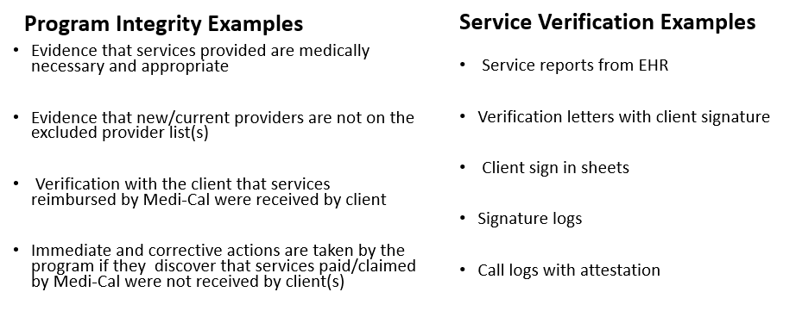
How to Complete: Speak with your COR about PI/PV outlined in your program’s Policies & Procedures (P&P’s).

Incident Reporting

What It Is: A reportable incident is an incident that may indicate potential risk/exposure for the County operated or contracted providers, client, or community.
- There are two (2) primary types of Incidents – Critical and Non-Critical
- Timelines: All providers are required to report \ incidents involving active clients or whose discharge from services has been thirty (30) days or less within twenty- four (24) hours of knowledge of the incident.
- Critical Incident Categories:
  - Death/Pending (Pending CME investigation)
  - Suicide Attempt
  - Critical Injury on site (MH/SUD related)
  - Death/Natural Causes (Confirmed)
  - Death/Overdose (Confirmed)
  - Non-Fatal Overdose
  - Medication Error
  - Death/Homicide (Confirmed)
  - Death/Suicide (Confirmed)
  - Alleged abuse/inappropriate behavior by staff
  - Injurious assault by a client resulting in hospitalization
  - Adverse Media/Social Media Incident (only; no leading incident)

- Non- Critical Incident Categories

  - AWOL
  - Contract/Policy violations by staff
  - Loss / theft of medication from the Facility
  - Physical Restraints
  - Tarasoff Reporting
  - Adverse Police/PERT Involvement onsite
  - Medication Error
  - Non-critical injury onsite
  - Property destruction onsite
  - Other

Why It Is Required: When an Incident occurs or are identified, the appropriate agencies must also be notified within their specified timeline and format (i.e. police, child/elder abuse hotlines, other law enforcement, fire department, etc. It is also required that the program look into any incidents that happen on site and/or follow up with clients who have exhibited dangerous behaviors via referral to appropriate resources / emergency sources as needed.
How to Complete: All information for Incident Reporting: webinar trainings, submission forms, tip sheets and further resources are located on the Optum Website> Incident Reporting tab and OPOH Section G.

- Critical Incidents are reported using the CIR Form located on the Optum Website > Incident Reporting tab
- N-CIRs are reported directly to your COR/Program Manager and to QA via an online submission form located on the Optum Website with NO identifying Protected Health Information (PHI).
- Please reference the tip sheets and webinars posted on Optum for step-by step instructions on how to fill out each document.

Timely Access Data Standards (TADT)
SmartCare: MH Non-Psychiatric SMHS Timeliness Record

What It Is: Access time refers to how long a client must wait to get a service at your program from the date the service was requested. For example, in an outpatient clinic with a limited number of staff, clients may not be able to get an appointment with a therapist immediately.

The standard is the following for non-psychiatric appointments:

Non-urgent with nonphysician MH care provider (routine) – within ten (10) business days from request

Example: This means that if someone calls and says “I want to become a client with your program” you say “sure, come in and become a client” with access within the next ten (10) business days.

Why Is It Required: Long wait times for services can prevent clients in the County from getting the help they need. The State requires the TADT to make sure people are connected to care as quickly as possible or referred to another clinic with more availability instead of being left in limbo.

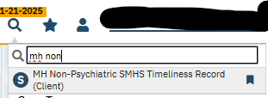
How To Complete:

- Look up the client in SmartCare

- Search for “MH Non-Psychiatric SMHS Timeliness Record”

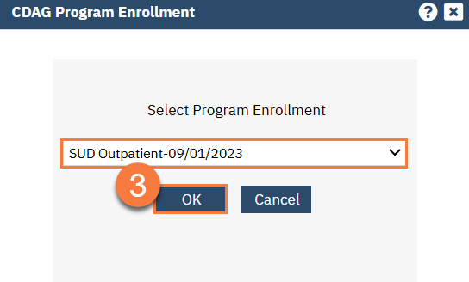
- Choose your program from the CDAG Enrollment Screen

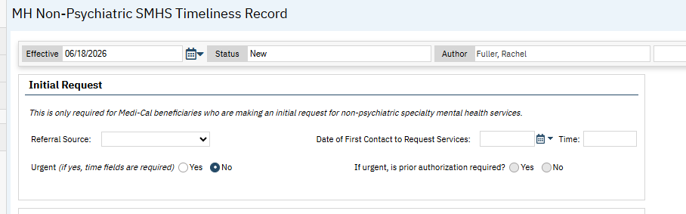
- Fill out the first section using the guidance below:

- Referral source

- Date of first contact to request services- the date and time you received the call from the client or the client walked in to request services

- IPS referrals will not be Urgent (no for both radio buttons)

- Fill out the second section using the guidance below:

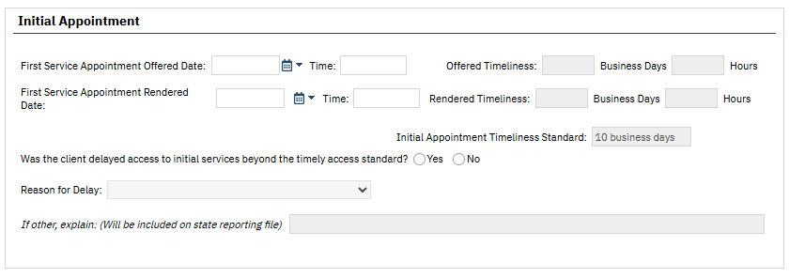

- First Service Appointment offered date: This is the first time/day staff has available to see the client and complete intake paperwork.

- For example, If the program’s hours are Monday- Friday 9am-5pm and staff are free any time to do an intake, then the “first service date/time” that day (i.e. June 18th at 9:00am).

- For example: A client calls at the very end of the day and wants to begin services. There may not be enough time for them to come in that day. In this case, the first service appointment date would be the next day (i.e. June 19th at 9:00am).

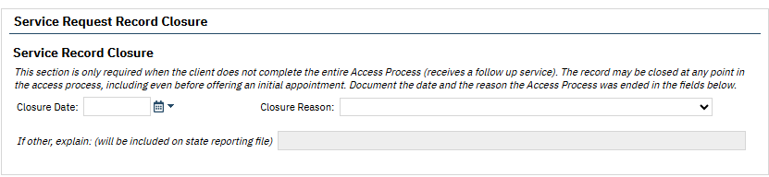
Bottom line: if from the time the client calls to request services is less than ten (10) business days from the first available appointment everything is within timelines.
- First Service Appointment Rendered Date: this is the date the client actually shows up for services. It can be filled out later if the first service appointment date and appointment rendered date are not the same.

- Reason for Delay

- The Follow Up Appointment section should not be completed. Select “N/A” radio button.
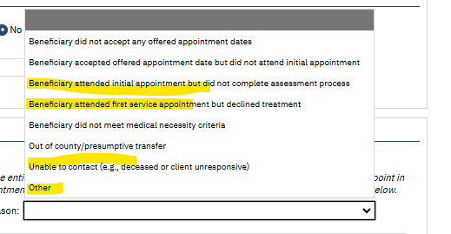
- Select “No” for Out of Network Referral section

- Service Request Record Closure

- This section should be completed for people who call and want to become a client but never come in. These should be closed at program discretion (i.e. at the end of each month, once per quarter, etc) with the appropriate reason for closure selected. The most likely reasons for closure have been highlighted in yellow in the picture above.

NOABD Logs

What It Is: NOABDs (Notices of Adverse Benefit Determination) are formal notifications required to be sent to client by providers which inform clients of the health plan’s adverse decision, determination reasons and criteria when requested health benefits, coverage, or services are denied, reduced, or terminated. NOABDs also explain their rights to appeal the decision.

Why It Is Required: An NOABD is required to ensure Medi-Cal clients receive timely, standardized, and legally compliant written notice when a decision is made that negatively affects their access to or payment for services.

How to Complete: There are eight (8) different kinds of notices all located on the Optum Website “NOABD” tab and outlined on the NOABD Tip Sheet found on Optum. Please become familiar with each one.

At IPS programs, you will likely (but now exclusively) use the following NOABDs:

- Delivery System Notice- It is issued when the programs determined that the client does not meet the criteria to be eligible for services (i.e. the client does not have a Serious Mental Illness) and makes a referral to a more appropriate system of care.

- Timely Access Notice- When requested services (i.e. enrollment into the program) cannot be provided within timelines ten (10) business days from date of request).

- Termination Notice- The program is terminating a client from the program (i.e. due to disengagement, client unwilling to continue services, etc)

Client Programs Enrollment & Discharge
SmartCare: Client Programs (Client)
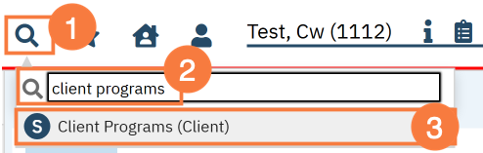
- Search for “Client Programs” under the client’s file in SmartCare

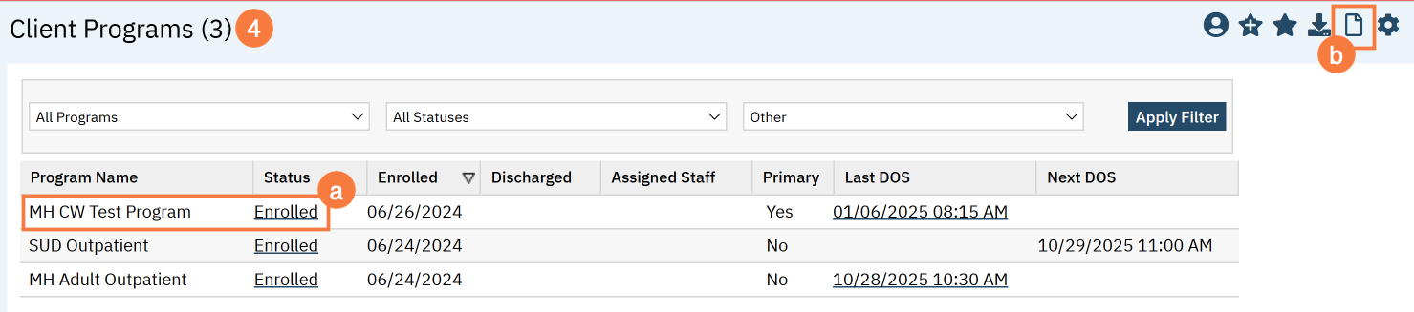
- Select the program (a) or add the program with the “new” icon (b)

- Change client status to “enrolled” or “discharged”

- Select your program from the dropdown menu.

- Enter the status “enrolled” or “discharged”

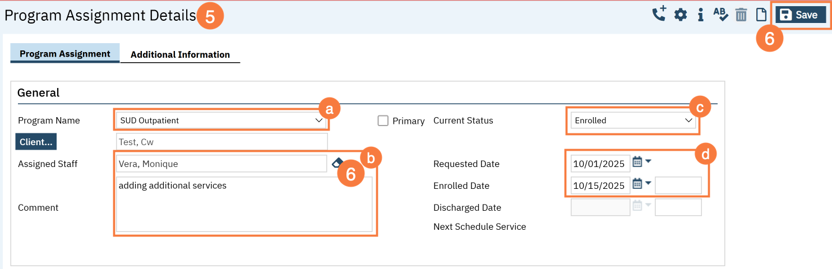
- Enter the enrollment / discharge date. This will be today’s date. You may leave the requested date blank, if it is not already entered.

Discharge

What It Is: A client has decided they no longer wish to participate in the program, has been out of contact for an extended period despite outreach efforts, or has requested to close their engagement for another reason.

Why It Is Required: Completing the discharge process also fulfills State documentation and reporting requirements.

How to Complete: Whenever possible, have a conversation with the client about their transition. Discuss any ongoing supports that may be helpful, including community resources, crisis contacts if appropriate, medications (when applicable), and any follow-up services they plan to access. Document the client’s reason for discontinuing participation at this time, any transition planning that occurred, and complete the required SmartCare steps to close the client’s enrollment in SmartCare.

Intake Packet Requirements

- Advance Directive- Required to be provided to the client at the first face-to-face with the client or upon turning eighteen years old (18) and documented in the client’s record and whether the client has an existing Advance Directive.

- Voter Registration- The voter registration is required to be offered at intake and documented.

- Language/Interpretation services and availability

- Problem Resolution (Grievance & Appeal) process and brochure- Grievance/appeal process information and State Fair Hearing is required to be provided to new clients upon first admission and annually and must be documented as explained/given to the client.

- BHP Notice of Privacy Practice

- Provider List- Programs can choose to provide the entire list or instructions for how to locate the list online

- Guide to Medi-Cal Healthcare services brochure is required to be provided when new clients first obtain services – this should be monitored via Attestation vs every three (3) years at recert.

Please see the Optum website> Beneficiary tab for further information and for printable copies of required documents.

CSI Standalone Collection
SmartCare: CSI Standalone Collection

What Is It: A Client Services Information (CSI) record must be completed in SmartCare for:
- Admission
- Annually
- Discharge

Why is it Required: This is a State requirement for demographic information.

How to Complete: It should be filled out with as much information as possible. Although there is a downtime form for this document it MUST be entered electronically into SmartCare so the data can be provided to the State.

ASCMI
SmartCare: ASCMI (Non-AB 133 form)

What Is It: The ASCMI Form is a standardized consent to share information form that
providers will use to obtain an individual’s consent to share certain sensitive
physical health, behavioral health, housing, and social services information
across providers outside of the electronic health record. The ASCMI Form is a release of information form you can use to request your client’s consent to share their information with providers that are also a part of their care team. The form is meant to improve care coordination across multiple providers

Please note- only one of these documents is required per client in SmartCare. If the client already has an ASCMI form in SmartCare it does not need to be re-completed. The ASCMI form needs to be updated annually.

Why is it Required: The ASCMI is required to be offered to every client. If it is completed on paper it must be entered electronically into SmartCare. Even if clients decline to sign the form, it still must be completed and their option to decline can be marked on the form. Although there is a downtime form for this document it MUST be entered electronically into SmartCare so the data can be provided to the State.

How to Complete: How to Complete the ASCMI - 2023 CalMHSA

Consents
SmartCare: Consent to Treat (Client), Consent for Telehealth (Client), Consent for Text Communication (Client), Consent for Email communication (Client)

What Are They: A consent is the formal agreement that a client voluntarily authorizes staff to offer and deliver specific mental health treatments or provide information to them via certain forms of communication. The client has been given sufficient information about the proposed treatment, including its purpose, expected benefits, risks, alternatives, and what might happen without treatment. Additionally, consent for telehealth in mental health requires that clients are fully aware of what to expect during a remote session and privacy measures, such as using headphones, and understanding that electronic communications carry some risk of interception or unauthorized access.

Why Are They Required: Consents are required in Specialty Mental Health Services (SMHS) to ensure that clients are fully informed, voluntarily agree, and understand the nature of the services they are receiving. The ASCMI and the Consent to Treat are the only specific consent form that is required- programs may use their own consents as long as they have all required elements and are uploaded into SmartCare.

How to Complete: Consents (Client) List Page - 2023 CalMHSA

Signature Logs

What It Is: A Signature Log is a list of all current staff providing direct services, their degree/licensure, job title, language capability (if applicable) and a copy of their typical signature. It is maintained at the program typically in a binder on paper.

Why Is It Required: All providers are required to maintain an accurate and current staff log signature. It is very important that the signature on the log be readily identifiable to the staff’s name as it appears on paper documents as well as in the EHR. For example, if a staff member goes by “Nick” but his name in the EHR is “Nicholas” please record this in the signature log. It is the organizational provider’s responsibility to update and maintain the log in a timely manner to reflect any changes, i.e., licensure, degree, job title, name, or signature.

How to Complete: OPOH Section G for more information.

Special Population Tracking
SmartCare: Special Populations (Client)

What It Is: A “flag” on client’s charts to identify if are part of a “special population” such as probation, LPS Conservatorship, homelessness, etc.

Why It Is Required: Tracking of homelessness is required for all BHS funded programs for data tracking purposes.

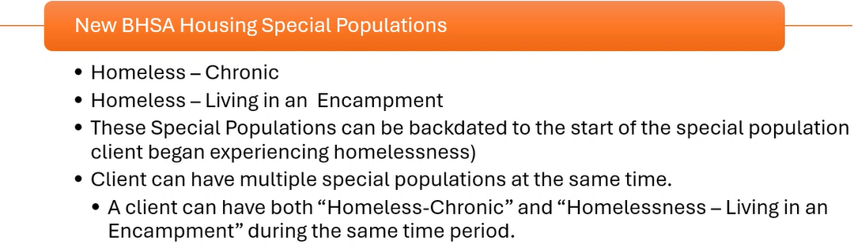
Homeless clients must have this added as a special population using the best fit description of one of the following below:

Please note: If the client does not know the exact date they became homeless, staff can use their best estimate.

How to Complete: How To Identify a Client as Katie-A or Other Special Population - 2023 CalMHSA

Billing & Medi-Cal Payment

SPA 24-0051 authorizes BHP programs to provide IPS as a bundled service with a unique billing code and monthly bundled rate. San Diego County has opted into the bundled rate for IPS services. Prior authorization is not required for IPS Supported Employment.

Supported Employment CBT Code: H2023

Verifying Medi-Cal Eligibility

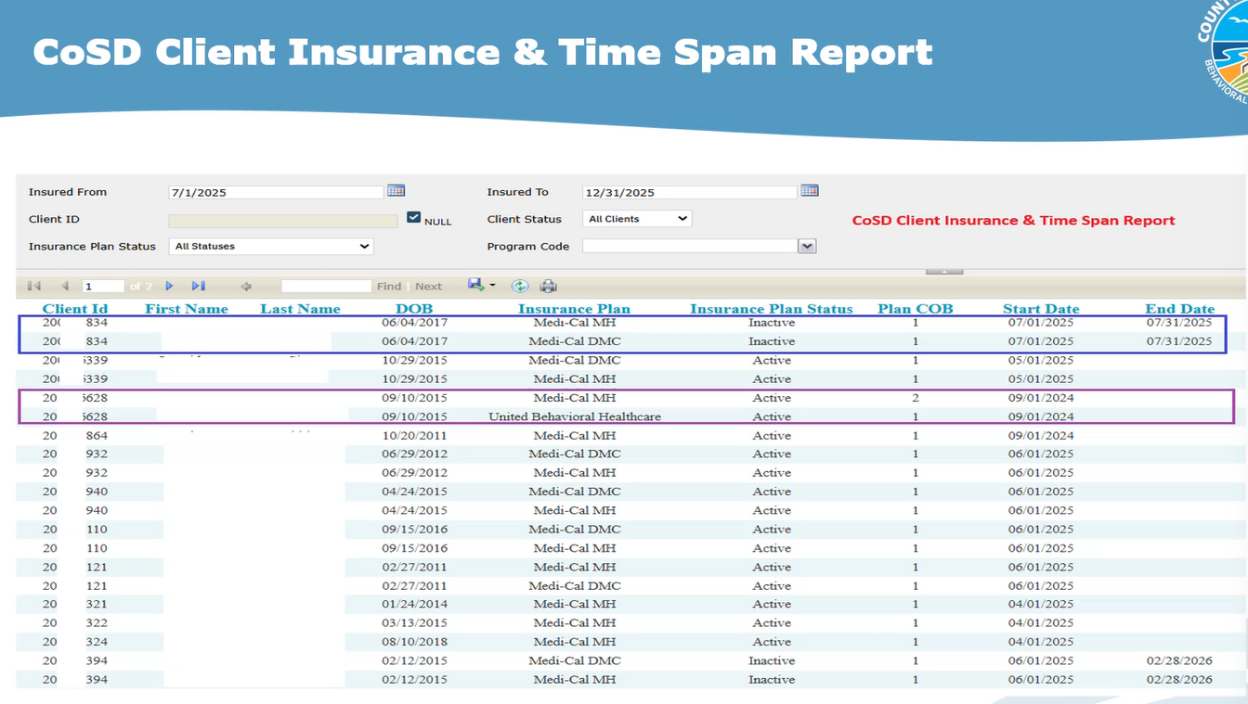
Specialty mental health clients must be enrolled in Medi-Cal for the BHP to be reimbursed through the SD/MC claiming system. BHPs should verify member Medi-Cal eligibility for the month of service prior to submitting claims for reimbursement.
Use the links below to read about how to enroll in the provider portal to determine member Medi-Cal eligibility.

- Registering to Verify Eligibility on the Medi-Cal Provider Portal
- DHCS - Provider Portal

UMDAP Financial Assessment
UMDAP Financial Assessment (Client)

Medi-Cal offers health care coverage to individuals and families whose income exceeds the maximum allowable by requiring these members to contribute to their health care by paying a share of the cost for the services they received. UMDAP was developed to establish a statewide method of determining the ability of the client or financially responsible person to personally contribute to covering the cost of specialty mental health services received. The State requires counties to apply the Uniform Method of Determining Ability to Pay (UMDAP) during financial screening, which includes a standard sliding scale fee to determine the member’s liability amount.

Timeline: The UMDAP annual charge period is valid for a period of (1) year

If a member refuses to sign the UMDAP: A member is considered to be “Full Pay” if he/she does not respond to request for financial information or refuses to provide financial information or verification, if requested. This is recorded by not placing a checkmark in the box for the financial information provided/verified and entering R= not provided/refused in the reason list.

Resources: UMDAP Financial Assessment in SmartCare.pdf

SmartCare Client Plan Request Form

Programs are required to complete this plan request form and submit it to the BHS Billing Unit (MHBillingUnit.BHS@sdcounty.ca.gov )for members who have a primary health plan that needs to be added to their coverage plan in SmartCare.
This form is required for:
- New clients in the system of care
- Members who do not have any active insurance plans in SmartCare
- Members whose coverage changes or expires
Resources:
- Guidelines_on_Completing_the_SmartCare_Client_Plan_Request_Form.pdf
- SMH & DMC-ODS Health Plans > SmartCare Tab> Billing> SmartCare Client Plan Request

Monthly Bundled Services In SmartCare - Resources

- Optum Website> SmartCare Tab> Workflows and Documentation> SmartCare IPS EBP BH Connect Monthly Bundled Service Entry Workflow

  - A step by step guide of how to monitor for services and bill the bundled rate at the end of the month.

- Optum Website>MH Resources> IPS Supported Employment > IPS EBP Monthly Bundled Rate Explanation Guide

  - Explains the basic outline of the requirements for, as well as the type and number of services qualify for the Full or Partial monthly rate in various settings.

- Optum Website>MH Resources> IPS Supported Employment > IPS Service Activities Procedure Code Crosswalk

  - Identifies all allowable service codes for this EBP as well as descriptions to help providers determine who can and should utilize each code.

Medi-Cal Rates for IPS

- Full monthly rate

- Medi-Cal members that receive at least four (4) contacts on four (4) different days in a month

- At least three (3) are delivered face-to-face (in-person) with the client.

- Other contacts may be with a collateral (i.e., family member and/or significant support person).

- If there are two (2) or more contacts on the same day, at least one (1) of which is with the client and one (1) of which is with a collateral, it may be counted as two (2) separate days.

- In most cases, the full rate will be utilized during the delivery of pre-employment services, when clients meet regularly with their IPS team during their job search.

- Partial monthly rate

- Medi-Cal members that receive at least two (2) contacts on two (2) different days in a month, of which at least one (1) contact is delivered fac to-face (in-person) with the client.

- Other contacts may be with a collateral (i.e., family member and/or significant support person).

- If there are two (2) or more contacts on the same day, at least one (1) of which is with the client and one (1) of which is with a collateral, it may be counted as two (2) separate days.

- In most cases, the partial rate will be utilized when the client has secured a job and requires ongoing follow-along support on a less frequent basis.

Definitions

- A “contact” = an encounter of at least fifteen (15) minutes in duration.

  - Only one (1) contact per day may be “counted” for payment purposes.

  - While IPS teams must deliver the minimum contacts required for the BHP to claim either the full or partial monthly bundled rate, IPS teams are expected to provide as many contacts as needed to support a client’s recovery.

  - The number of contacts per client may vary over the course of their treatment.

Telehealth

- While telehealth can support delivery of IPS, for the BHP program to claim the full monthly rate at least three (3) contacts with the client must be conducted face-to-face.

- To claim the partial bundled rate for IPS, at least two (2) contacts with the client must be conducted face-to-face.

- Additional contacts with the client, contacts with collaterals, and team administrative functions (e.g., team meetings) may be conducted virtually.

Exceptions

- Inpatient & Residential Settings: IPS Supported Employment services may not be delivered in inpatient or residential settings. Services may be provided to clients during their inpatient or residential treatment stay; however, the IPS Supported Employment team must meet with the client in a community-based location.

- Correctional Facilities & Jail Settings: The primary Medi-Cal services available to individuals while incarcerated are the targeted pre-release services authorized under the CalAIM Justice-Involved Initiative (which can be provided in the ninety (90) days prior to release)

- The components of the bundled IPS service may not be claimed as unbundled service components.

Preventing Fraud, Waste & Abuse

Fraud means an intentional deception or misrepresentation made by a person with the knowledge that the deception could result in some unauthorized benefit to himself or some other person. It includes any act that constitutes fraud under applicable Federal or State law.
- Examples:
  - Deliberately claiming for services that were not provided: A staff member claims they met with a client and completes a note when the client cancelled the session for that day.

  - Falsifying records or duplicate billing: A staff member writes that they met with a client for sixty (60) minutes and provided rehabilitation interventions, when they only had a brief five-minute conversation.

  - Copying and Pasting Notes: A provider copies the exact same progress note for multiple visits, changing only the date, even though the services and client responses were different.

Waste is the overutilization or misuse of services, or other practices that, directly or indirectly, result in unnecessary costs to the Medicare program. Waste is generally not considered to be caused by criminally negligent actions but rather the misuse of resources.
- Examples:
  - Providing services/procedures/medications that are not medically necessary : A client is doing well and only needs monthly support, but the provider routinely schedules and bills three sessions per week without a documented clinical reason.
Abuse includes actions that may, directly or indirectly, result in: Unnecessary costs or reimbursement to the Medicare Program, improper payment, payment for services that fail to meet professionally recognized standards of care, or services that are medically unnecessary
- Examples:

  - Billing a service which knowingly did not take place: A staff member documents and bills a one service even though they never met with the client.

Mental Health Assessment
SmartCare: Mental Health Assessment

What It Is: The mental health assessment is not meant to feel like a clinical interview. Instead, think of it a conversation that helps gather information that helps the job seeker get and keep competitive employment?

For example, instead of saying “We are going to complete a mental health assessment”, you can say: "I'd like to learn about you so we can understand what kind of work fits you, what has helped you succeed in the past, and what gets in your way. That helps us figure out how IPS can best support you."

Why It Is Required: Every Medi-Cal client receiving Specialty Mental Health Services (SMHS) must have an assessment but it can be framed as a “getting to know you” conversation. The questions and answers throughout this conversation can help inform other important tasks and paperwork such as the Career/ Employment Profile.

Licensed vs. Non-Licensed Staff members

- Non-licensed staff can gather much of the assessment information through conversations with clients.

- Licensed staff must co-sign the assessment and complete the clinical portions of, including:

  - Mental Status Examination (MSE) – Domain 1
  - Clinical Summary- Domain 7
  - Diagnosis - Domain 7
  - Medical Necessity- Domain 7
  - Level of Care- Domain 7

Licensed providers may use information gathered by non-licensed staff, documenting:
"Information obtained by [Provider Name, Credential]."

How to Complete: *Please see Appendix Section for a sample Mental Health Assessment & Cheat Sheet

There is no time limit (within reason) as to how long the assessment process can be. For example, some programs find it easier to complete the assessment over 2–3 visits, allowing time to build trust and get to know the client.

If the Client Already Has an Assessment:

If the client recently completed an assessment with another behavioral health provider, IPS staff may:

- Review the previous assessment.

- Gather information to complete Sections 1 and 7 specific to the IPS program

- Information from sections 2-6 may be pulled forward (via copy/paste) into the IPS assessment.

  - At the top of each section 2-6 include the statement: "The following information was reviewed and accepted from a previous assessment dated [date] and completed by [previous program]”.

- A licensed clinical staff will need to co-sign the assessment for completing the clinical sections.

When Should Assessments Be Updated?

Update the assessment whenever there is a significant change in the client’s life:

- Psychiatric hospitalization
- Housing changes
- Employment changes
- Significant increase or decrease in symptoms
- Major life events
- New recovery goals

All seven (7) domains are required to be completed in the assessment. They are outlined below with some examples questions that may help gather necessary information.

Domain 1: Presenting Problem

Please note this section should include a Mental Status Exam that must be completed by a licensed clinical staff member.

Example questions:

- What made you interested in employment right now?
- What brought you here?
- What are you hoping to get out of services here?
- What has been making life harder lately?
- If things were going really well in six months, what would your life look like?

Remember to connect these concerns to how they affect the person's daily life and mental health.

Domain 2: Trauma

- Only ask enough to understand whether trauma has affected the client’s functioning. Clients do not need to share details if they are uncomfortable. This can also be asked by the licensed staff member.

  - Example question: Have you ever experienced anything deeply troubling or upsetting in your life that you think may have affected your ability to get or keep a job?

Domain 3: Behavioral Health History/Co-occurring Substance Use

Learn about previous behavioral health treatment and substance use.

Example questions:

- How has your mental health affected work or school?
- Have alcohol/ drugs ever gotten in the way of school or work?

Domain 4: Medical History/ Current Medications / Co-Occurring Disorders

Learn about current physical health and medications.

Example questions:

- Are you taking any medications?
- Do you have any medical conditions?
- Do you have a primary care doctor?
- Do medications or health issues affect your workday?

Domain 5: Social and Life Circumstances/ Culture/ Religion/ Spirituality

Learn about the client’s life.

Example questions:

- What does a typical day look like?
- Have you worked before?
- Would you like to work again?
- Are you interested in school?

- What responsibilities, transportation, culture, finances, or housing affect work?

Domain 6: Strengths, Risk Behaviors and Protective Factors

Strengths: What is going well.

Example Questions:

- What are you really good at?
- What are you proud of?
- What helps you through difficult days?
- Who supports you?
- What kinds of work or hobbies do you enjoy?

Risk Behaviors: Explain- "I ask everyone these questions because we want to make sure everyone is safe."

- When stress increases at work, what usually happens?"
- Have you had thoughts of hurting yourself or others?
- Do you feel safe today?

Domain 7: Clinical Formulation & Diagnosis

Please note this section must be completed by a licensed clinical staff member.

The licensed clinician will complete:
- Clinical Summary
- Diagnostic Impression
- Medical Necessity
- Level of Care
- Clinical Recommendations

Diagnosis Document
SmartCare: Diagnosis Document

What It Is: Each program must have a program-specific Diagnosis Document that matches the symptoms and client presentation described in the notes and the most recent assessment.

Why It Is Required: This is required in order to bill for services.

How to Complete:

- The actual diagnosis and justification for the diagnosis must be completed by a licensed/waivered clinician or a clinical trainee with co-signature/registered clinician. - CALMHSA Documentation Guide- Appendix III (pg. 39)

- IF a licensed clinician cannot meet with the client for the first session, a Z code can be given to the client in order to temporarily bill.

  - Z codes may be used temporarily as a primary diagnoses during the assessment phase of Specialty Mental Health Services (SMHS) when a formal mental health diagnosis has not yet been established, provided documentation supports medical necessity.

  - Some common Z codes might be:

    - Z93.89 Encounters where a patient is evaluated for a suspected disease or condition, but after examination and testing, the condition is ruled out
    - Z59.0 Homelessness
    - Z59.5 Extreme poverty
    - Z56.0 Unemployment, unspecified

  - Complete list of Z codes: V Codes (DSM-5) & Z Codes (ICD-10) - PsychDB

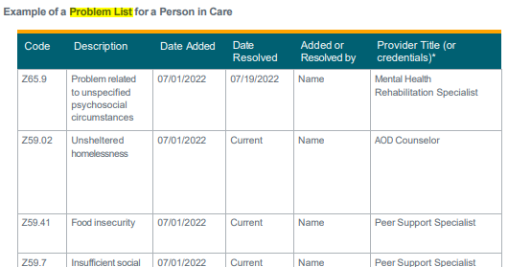
Problem List
SmartCare: Client Clinical Problem Details

What It Is: A problem list is a list of a client’s symptoms, conditions, diagnoses, and risk factors. A Problem list is required for all clients.

Why It Is Required: It serves as an organized snapshot of a client’s treatment needs and is essential for coordinated care.

How to Complete: How to Add a Problem to the Problem List - 2023 CalMHSA & How to Remove a Problem from the Problem List- 2023 CalMHSA

- Updates to problem lists: Staff should update the problem list when a client reports a new issue in their life or observation of additional/ resolved issues.

- There is only one (1) problem list needed per client. This means that multiple providers may be adding to the same problem list.

  - Before you add a new problem to the problem list, please review the current problems to make sure it is not already on the list. If it is, there is no need to add it again.

  - If a client is open to another provider and has a Problem List already, the IPS program should review the current Problem List with the client and document that the list was reviewed with the client and accepted/ or changed.

- Please note that the problem list may include the diagnosis, but it is not required

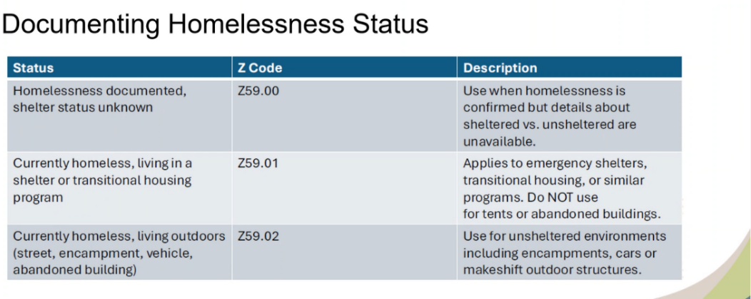
- It is required for all BHS funded programs that if a client is homeless it is on the Problem List by one of the following Z codes:

Service Note
SmartCare: New Service Note

What It Is: All clients must have a service note for each billable service. Notes must be signed in order to be valid.

Why It Is Required: Notes are used to document the treatment that has occurred and may serve as communication tools to alert other providers of the status of treatment. Each progress note shall provide sufficient detail to support the service code(s) selected for the service type(s).

How to Complete: How to Write a Progress Note for a Scheduled Service - 2023 CalMHSA

Timeframe: Providers shall complete progress notes within three (3) business days of providing a service, with the exception of notes for crisis services, which shall be completed within one (1) calendar day. The day of the service shall be considered day zero (0).

Staff will select the procedure code that best fits the service provided utilizing the IPS Service Codes Procedure Crosswalk located on the Optum Website>MH Resources> IPS Supported Employment > IPS Service Activities Procedure Code Crosswalk
Note requirements: (BHIN 23-068)

- The type of service

- The date that the service was provided

- Duration of direct patient care for the service.

- Location or place of service

- A typed or legibly printed name, signature of the service provider, and date of signature.

- A brief description of the service provided and how the service addressed the client’s behavioral health needs (e.g., symptom, condition, diagnosis, and/or risk factors).

- A brief summary of next steps

- In all documentation, it is beneficial to include direct quotes from the client.

- The correct service type must be billed (i.e. Psychsocial Rehab vs. TCM/ICC)

- Next Steps: Short-term actions the member will take before the next visit or the next weeks.

  - i.e. the building blocks that help you reach your goal
  - Must be documented in each service note
  - Should change every service note

The key is to stop framing IPS as simply “helping someone get a job” and instead connect the employment intervention to the client’s behavioral-health condition, functional impairment, and recovery needs.
- Example:
Client’s mental health symptoms of poor concentration, anxiety, low motivation and poor distress tolerance contribute to difficulty with concentration, anxiety in social situations, inconsistent attendance, and difficulty managing stress. These symptoms have resulted in difficulty in maintaining employment and numerous employment attempts. IPS is being provided to help the member develop and use strategies to manage these behavioral-health-related barriers while pursuing and maintaining competitive employment.
That is much stronger than: “Helped member apply for jobs.”
IPS addresses the functional impact of mental illness on the member's ability to obtain and retain employment.
- Examples:
“Member's depressive symptoms have contributed to difficulty initiating and completing multi-step tasks. IPS staff provided structured coaching to help member break the employment application into manageable steps and reinforced strategies to initiate and complete tasks independently.”

Mental Health Symptom | Employment Impact | Interventions
Anxiety | Avoids interviews/employers | Gradual exposure, interview preparation, coping strategies
Depression | Low motivation/initiation | Breaking tasks into steps, activation strategies
Psychosis | Difficulty interpreting workplace interactions | Role-play, workplace communication strategies
Cognitive symptoms | Difficulty remembering tasks | Organizational strategies and accommodations
Social anxiety | Avoids communicating with supervisors | Communication practice and problem-solving
Mood instability | Difficulty maintaining routine | Employment routine and symptom-management planning
Trauma-related symptoms | Difficulty tolerating certain environments | Identifying appropriate work environments and coping strategies
Medication side effects | Fatigue or difficulty maintaining schedule | Coordination with treatment team and employment planning

Four Questions to ask yourself before writing a note:

- What mental-health-related problem is affecting employment?

Example: Anxiety

“Client reports increased anxiety when communicating with unfamiliar people, which has contributed to avoidance of employer contacts.”

- What functional impairment resulted?

Example: Avoids interviews and searching for jobs

“Client’s anxiety has interfered with initiating employer contacts and participating in interviews.”

- What did IPS staff actually do about it/ How did I help?

Example: Role play, education

“IPS staff educated client on various ways to contact employers and used role-play to address anticipated interview anxiety.”

4. What was the client’s response?

For example:
“Client identified anxiety as a primary barrier to employment. He reported increased confidence and identified use of breathing and preparation strategies as helpful.”

Behavioral-health barrier + functional impact + IPS intervention + member response + next step

Example:
Member experiences anxiety when interacting with unfamiliar individuals (Barrier) +
This has contributed to avoidance of employer contacts and difficulty participating in interviews. (Functional Impact) + IPS staff provided education and role-play focused on initiating employer contact and managing anxiety during interviews. (Intervention) + Client participated in role-play and demonstrated increased ability to identify and use coping strategies. (Response) + Client will contact two identified employers before the next IPS meeting. (Next Step)

Remember: Activity does not equal Intervention

Activity | Intervention
Applied for a job. | Supported member in applying for a job because depressive symptoms have interfered with initiation and completion of employment-related tasks; staff provided structured prompting and task segmentation to increase independent functioning.
Practiced interviewing. | Used role-play to address member's anxiety and difficulty communicating with unfamiliar individuals, with emphasis on developing strategies that will allow member to participate more effectively in employment interviews.
Went with member to employer. | Provided individualized support during employer contact to help member manage anxiety and practice communication strategies in a real-world employment setting.

Client Safety

While the IPS program is not a crisis or emergency mental health service, staff play an important role in recognizing when a client may need additional support and helping them connect to appropriate resources.
If a client expresses that they feel unsafe, is talking about harming themselves or others, or appears to be experiencing a mental health crisis:
- Stay with the client whenever possible and remain calm,

- Listen without trying to solve the crisis. Allow the client to share what they are experiencing and acknowledge their feelings.

- Notify a supervisor immediately.

- Assess the level of urgency. If there is an immediate threat to the client’s safety or the safety of others, call 911.

- Document the interaction and any actions taken according to program and County requirements.

Emergency Resources (County of San Diego)
- Immediate danger or medical emergency: Call 911.
- County of San Diego Access & Crisis Line (24/7): 888-724-7240 (7-1-1 TTY)
- 988 Suicide & Crisis Lifeline: Call or text 988 for immediate emotional support and suicide prevention assistance.
- Psychiatric Emergency Response Team (PERT)
  - Referrals to PERT are made through the 911 dispatch operator.

  - Provides emergency assessment and referral for individuals in behavioral health crisis. Pairs licensed mental health clinicians with uniformed law enforcement officers/deputies.

- Mobile Crisis Response Team (MCRT) - MCRT Fact Sheet
  - MCRT is deployed through calls made to the San Diego Access and Crisis Line (ACL) (888-724-7240) or emergency services. Trained dispatchers will assess the situation for risk and safety through a series of questions and will determine if MCRT or another crisis intervention or response service should be sent out.
  - Please note that MCRT can respond to behavioral health crisis calls that do not involve medical emergencies, weapons, or known threats of violence.
If the situation is urgent but not life-threatening the following resources can be utilized:
- Access & Crisis Line: 888-724-7240 (7-1-1 TTY) : Assist the member in connecting with the County of San Diego Access & Crisis Line (ACL), which is available twenty- four (24) hours a day, seven (7) days a week. The ACL provides crisis intervention, behavioral health referrals, and can dispatch the Mobile Crisis Response Team when appropriate.

- Clinical provider: If the member is connected to other treatment providers (i.e. outpatient clinic, therapist, etc.), encourage the member to contact their mental health provider, psychiatrist, therapist, or other trusted support person if appropriate.

- Safety Plan - A Safety Plan may be completed if the staff feel it is beneficial to the client. A copy of Safety Plan should be offered to client and signed.

- Documentation: Staff may choose to use the safety plan in SmartCare, the sample safety plan in the Appendix of this handbook or create their own. The safety plan should be kept in the member’s physical chart (if utilized) or uploaded into SmartCare.

Using the EHR (SmartCare)

SmartCare Training

Prior to staff obtaining access to SmartCare, they shall successfully complete all applicable SmartCare trainings. Program managers are responsible for registering new and returning SmartCare users for training on the CalMHSA LMS application. Previous users returning to employment (including maternity leave) after more than ninety (90) days of absence will be required to resubmit new paperwork including an updated ARF and be evaluated for a skills assessment or retraining.
Users are required to attend and pass the assigned online LMS trainings with CalMHSA prior to access. Staff will be responsible for trainings according to their Staff Role. The CalMHSA Required Trainings by Role Grid can be found on the Optum Website under the SOC Resources and Training. See the following grid for guidelines : SmartCare Trainings by Staff Role. For additional resources, please see: SmartCare User Training Registration and SmartCare Training Tips

SmartCare Workflow

Action | What is it Called in SmartCare | Staff | Resources/ Guidance
- Look up the client to see if they are in the system yet. | Inquiries (My Office)  DO NOT USE DISPOSITION SECTION | Any staff with SmartCare access | Search by name, DOB, and SSN before you can create a new .client in the system to prevent duplicates.  How to Document an Inquiry - 2023 CalMHSA
- Complete Timeliness Record (TADT) | MH Non-Psychiatric SMHS Timeliness Record | Any staff- If completed on paper, info must be entered into SmartCare in a timely manner | *NOABD to be completed if timeliness is unable to be met.  MH Access Times Tip Sheet  How to Document Timely Access Record Information for TADT - 2023 CalMHSA
- Enroll client to the program | Client Programs (Client) | Any staff with SmartCare access | How to Add the Client to Your Program - 2023 CalMHSA
- Complete consents | ASCMI (Non-AB 133 form)  (if one has not yet been completed- only one needed per client. Must be updated annually)  Consent to Treat (Client)  Consent for Telehealth (Client)  Consent for Text Communication (Client) - (if applicable)  Consent for Email Communication (Client) - (if applicable) | Any staff- If completed on paper, info must be entered electronically (i.e. not scanned) SmartCare in a timely manner | Must use: ASCMI must be completed electronically in SC (even if client declines to sign).  All other consents are optional and should programs choose to use their own, they can scan copies into the system as needed.  How to Complete the ASCMI - 2023 CalMHSA
- Complete required State forms | CSI Standalone Collection | Any staff with SmartCare access | How to Complete a CSI Demographic Record - 2023 CalMHSA
- IF APPLICABLE:  UMDAP  Client Plan Request Form | UMDAP Financial Assessment (Client) (if one has not been completed- only one per member. Updated annually)  Paper Document - (if one has not been completed- only one per member. Updated annually) | Any staff with SmartCare access | UMDAP Financial Assessment in SmartCare  How to Complete the SmartCare Client Plan Request Form  Optum Website> SmartCare Tab> Billing
- Conduct assessment | Mental Status Exam (Client)  Mental Health Assessment (Client) | Information may be gathered by any staff but specific sections may only be completed by a licensed, waivered, registered staff: the MSE, diagnosis and clinical formulation | Mental Health Assessment - 2023 CalMHSA
- IF APPLICABLE:  Identify special population if applicable (homeless) | Special Populations (Client) | Any staff with SmartCare access | How To Identify a Client as Special Population - 2023 CalMHSA
- Establish diagnosis | Diagnosis Document (Client) | Only LPHAs have access in SmartCare | How to Document a Diagnosis - 2023 CalMHSA
- Establish problem list | Client Clinical Problem Details | Any staff with SmartCare access | * To complete if NOT done during the assessment phase or not being done when completing  the note.
- Write a note | New Service Note | Any qualified staff. | See “IPS Handbook” > Service Note section  BHIN 23-068  IPS Service Activities Procedure Code Crosswalk
- END OF THE MONTH  Bill for bundled services | COSD Client Services Report (My Office)  Services (Client) | Any staff with SmartCare access | IPS Bundled Service Entry Workflow  IPS Bundled Rate Explanation Guide
- Discharge | CSI Standalone Collection (Client)  Client Programs (Client)  CalMHSA Discharge Summary (Optional) | Any staff with SmartCare access | ** NOABD may needed depending on reason for discharge.  How to Complete a CSI Demographic Record - 2023 CalMHSA  How to Close a Client to a Program - 2023 CalMHSA  How to Complete the Discharge Summary - 2023 CalMHSA

Billing Corrections

- Optum > SMH & DMC-ODS Health Plans > SmartCare Tab > Billing Section

- Clearing CoSD Service Error Report (My Office)

- Payment Recovery Form

- Service Note Errors and How to Resolve (CalMHSA)

- How to Report an Error (CalMHSA)

Resources

Accreditation

Communications & Trainings
- Behavioral Health Information Notices (BHINs) are communications sent out by the Department of Health Care Services. They typically reflect important changes to rules and regulations. The QA department will “translate” and communicate important information to the system of care through UTTM’s (monthly emails) and QIP meetings.

- BHS Email Communications- Program staff can subscribe to the GovDelivery platform to receive BHS communications that go out to the system of care such as meeting notifications (e.g. QIP, SmartCare User Group, etc.), Information Notices, UTTMs (Up to the Minute Monthly Newsletters), BHINs, OPOH Updates, Upcoming Trainings (e.g. Audit Leads, Progress Note Practicum), etc.

  - The BHS GovDelivery Flyer includes step by step instructions to subscribe

    - To receive these notices as well as other important meeting invites and communications: Specialty Mental Health Services & SmartCare

- Up to the Minute (UTTM) - QA publishes a monthly newsletter to inform providers of important changes to regulations and/or requirements. This is one of the main tools for providing information to the system of care.

Documentation
- BHIN 23-068
- CalMHSA Clinical Documentation-Guide-04.2026.pdf
- CalMHSA Scope of Practice Matrix Appendix III (p.39)

Important Contacts
- QI Matters: QIMatters.HHSA@sdcounty.ca.gov- Primary email for the QA department. Staff are available for questions and consultation regarding various documentation and quality assurance issues.

- SmartCare system issues (glitches, functionality, pop up errors): CalMHSA Help Desk

- Support for questions that CalMHSA Help Desk can’t address/resolve (i.e. program / system changes, corrections or deletions): BHS_EHRSupport.HHSA@sdcounty.ca.gov

- Billing issues / questions: MHBillingUnit.BHS@sdcounty.ca.gov

- Access issues/questions, SmartCare ARF submissions: BHS_EHRAccessRequest.HHSA@sdcounty.ca.gov

- Questions related to documentation, guidelines or policy: QIMatters.HHSA@sdcounty.ca.gov

- Questions or requests regarding reports: BHS-DataScience.HHSA@sdcounty.ca.gov

- Privacy Incident Reporting and other Privacy Resources : All privacy incidents are reported directly through the HHSA Compliance Office online portal - HHSA Compliance Office

Important Websites

- Optum San Diego Website- SMH & DMC-ODS Health Plans & CalAIM for BHS Providers

  - Optum San Diego Website- SMH & DMC-ODS Health Plans > SmartCare Tab> Workflows and Documentation

  - Optum San Diego Website- SMH & DMC-ODS Health Plans> MH Resources> IPS Supported Employment

- CalMHSA Website: https://2023.calmhsa.org/

- The IPS Employment Center – Research, Dissemination, Training, and Consultation

- Organizational Providers Operations Handbook (OPOH) - The OPOH is a document containing a broad source of information for all topics involved in managing a program within the County of San Diego.

  - The most current version is always found on the OPTUM San Diego Website > OPOH tab.

Policy

- BHIN 25-009
- EBP Policy Guide- Rev. 5.1.25

Appendix

Sample Mental Health Assessment

Domain 1: List/Describe Presenting Problem(s), Current Mental Status, History of Presenting Problem(s) and Client Identified Impairment(s).

John is a 34-year-old male who would like to return to the work force following a two-year period of unemployment. John would ideally like to find a job in customer service, stocking, or within a warehouse. He reports that symptoms of depression, anxiety result in reduced motivation, difficulty concentrating, and intermittent suspiciousness. These have negatively affected his ability to consistently pursue employment opportunities. John has a history of becoming overwhelmed when asked to complete a chain of tasks or instructions and experiences intense anxiety during interviews and during interactions with strangers.

He reports that he has quit or been let go from previous jobs after he experienced increasing difficulty maintaining attendance, organizing tasks, and communicating with his supervisor when his symptoms “become really bad”. John identifies meaningful employment, increased financial independence, and development of a structured daily routine as goals he would like to accomplish through the program.

Mental Status Exam (Completed by Licensed Clinician – Rachel Fuller, LPCC₎

Appearance: appropriately dressed with adequate grooming and hygiene.
Behavior: Cooperative and engaged
Speech: Clear and within normal limits for rate and volume
Mood: intermittent anxiety and low mood
Affect: Restricted but appropriate to the discussion.
Thought Process: generally linear and goal directed.
Thought Content: No delusions or hallucinations reported
Orientation: Alert and oriented ×4 (person, place, time and situation)
Memory: Intact
Insight: Good
Judgment: Fair
Attention/Concentration: Mildly impaired during discussion of complex, multi-step tasks

Domain 2: List/Describe Trauma - Indicate N/A if not applicable.

John reports a history of family stressors that contributed to sensitivity to (perceived) rejection and criticism from others. John feels that this may be why he becomes very anxious in situations in which he feels he is “being judged” or evaluated, such as job interviews and interactions with supervisors. As a result, he has avoided these situations for the past two years.

Domain 3: List/Describe Behavioral Health History and Comorbidity.

John states his symptoms began in late adolescence. He has a history of intermittent treatment since that time. John acknowledges that symptoms have improved with consistent treatment and medication; however, during periods of increased stress or changes in routine. John becomes suspicious of his providers, which can lead to decreased participation in treatment.

John has previous employment history in retail and warehouse settings. He reports that maintaining employment became increasingly difficult when psychiatric symptoms increased, particularly due to difficulty with concentration, communication, attendance, and managing perceived criticism from supervisors. Client reports that these difficulties interfere with his ability to independently search for employment, participate in interviews, communicate effectively with employers, and maintain employment-related routines.

John reports occasional alcohol use and denies current use of other substances. He denies that substance use interferes with functioning.

Domain 4: List/Describe Medical History, Current Medications, Medication History, and Comorbidity with Behavioral Health.

John has no current medical conditions, although he does state that his medication can make him tired which can make it difficult to maintain a consistent routine. John is currently prescribed the following medications: [Document current medications, dosage, frequency, adherence, side effects] From Dr. Smith at New Life Clinic. John states he is currently consistently taking his medications as prescribed.

Domain 5: List/Describe Social and Life Circumstances and Culture/Religion/Spirituality.

John currently lives independently with family support. He says he has a limited social life, partially due to not having reliable transportation or money. He completed high school and has a history of employment but none currently. He identifies as “spiritual” and says that this provides meaning to his life.

Domain 6: List/Describe Strengths, Risk Behaviors, and Safety Factors.

John has the following strengths and protective factors with emphasis on those relevant to employment: a desire to work, previous employment experience, willingness to participate in IPS, identified goals (i.e. increased independence), positive relationships within his family and current medication adherence. John denies any intent to harm himself or others. He does not have any documented history of causing harm to himself or others.

Domain 7: List/Describe Clinical Summary and Recommendations, Diagnostic Impression, and Medical Necessity Determination/Level of Care/Access Criteria.

Completed by licensed clinician Rachel Fuller, LPCC

John presents with a history of schizoaffective disorder, depressive type, with ongoing symptoms including anxiety, low motivation, reduced concentration, difficulty managing interpersonal stress, and avoidance. These symptoms have resulted in functional impairments affecting occupational functioning. His behavioral health symptoms have contributed to difficulty initiating employment activities, communicating with employers, managing interview-related anxiety, maintaining routines, responding effectively to workplace stress, and sustaining employment during periods of increased psychiatric symptoms.

John demonstrates motivation to obtain competitive integrated employment and has identified employment as an important recovery goal. His identified behavioral-health-related functional impairments are appropriate targets for rehabilitation and skill development within an IPS model, as his symptoms interfere with his ability to obtain and maintain competitive employment independently. Some identified goals that can be addressed through treatment including: Managing anxiety during employment-related interactions, improving task initiation and completion and developing consistent employment routines.

Service Note Template

Client: __________________________ID#: ___________DOB: _______________

Status: ☐ Show ☐ No Show ☐ Cancel Cancel Reason: _______________

Program: ________________________________ Date: ______________________
Procedure: _____________________________ Start Time: _________________
Location: _______________________________ End Time: _________________
Staff: __________________________________ Face to Face Time: __________
Mode of Delivery: _________________________ Documentation Time: _________
Interpreter Services Needed ☐ Yes ☐ No Language: _______________

INTERVENTION (What staff actually did)

- Describe staff actions and (most importantly) how they are linked to the client’s identified stressors, problems, mental health symptoms and / or goals.

- Examples of intervention language:

  - Explored employment interests and preferences
  - Assisted with identifying competitive employment opportunities
  - Reviewed or updated resume
  - Assisted with completing job applications
  - Practiced/ role played interviewing skills
  - Contacted employers with member consent
  - Discussed workplace accommodations
  - Coordinated with employer (ROI on file)
  - Coordinated with treatment team
  - Discussed transportation planning
  - Addressed benefits or work incentive questions
  - Problem-solved barriers to employment
  - Supported job retention strategies
  - Provided psychoeducation regarding managing mental health symptoms in the workplace
  - Utilized motivational interviewing
  - Utilized strengths-based coaching

CLIENT RESPONSE

- Was the client engaged?
- Remember to tie interventions and client responses back to identified behavioral health symptoms, goals, stressors whenever possible. For example: Client stated that client stated that practicing interviewing with staff has “made him less anxious” which will help him feel more confident and prepared during interviews.

- Use quotes when possible

- Examples of client response language:
  - Fully engaged
  - Required prompting
  - Demonstrated increased confidence
  - Asked questions
  - Practiced employment skills
  - Identified solutions to barriers
  - Reported improvement
  - Applied for employment
  - Updated resume
  - Identified job opportunities
  - Practiced interviewing
  - Improved employment readiness
  - Maintained current employment
  - Developed coping strategies
  - Increased confidence

- Example Next Step language: At the next IPS session/ prior to the next IPS session, staff (and/or client) will:

- Follow up on submitted applications
- Continue job development
- Practice interviewing
- Coordinate with employer
- Coordinate with treatment team
- Look over the application for benefits
- Practice introducing himself to two people

Safety Plan (OPTIONAL)

When to Get Help
What are the warning signs that you are beginning to struggle? May include thoughts, feelings, or behaviors
1. _________________________________ 3. ______________________________________
2. _________________________________ 4. _______________________________________

Coping Skills
What can you do, by yourself, to take your mind off the problem?

1. ___________________________________3. ____________________________________
2. ___________________________________ 4. ____________________________________

Social Support
What connections do you have with family, friends, faith groups, communities, or pets? Where do you feel safe and supported? Who is the person(s) and contact(s) that you can openly talk about your crisis with?

1. _________________________________Number:___________________________ ____
2. _________________________________Number:________________________________

Emergency Contacts
1. 911
2. Psychiatric Emergency Response Team (PERT): Call 911 to contact
3. MCRT (Mobile Crisis Response Team): 9-8-8 or 1-888-724-7240
4. _______________________________________________________

Helpful Contacts
1. Access & Crisis Line (ACL): 1-888-724-7240_
2. 988 Suicide and Crisis Lifeline: Available 24/7, Call or Text 988
3. IPS Staff: ___________________________________________
4. _____________________________________________________________

Scanning Documents into SmartCare

- SmartCare Scanning Documents Job Aid - Oct. 2024.pdf

How to Associate Two or More Documents in SmartCare

- How to Associate Two or More Documents - 2023 CalMHSA

Client Alias in SmartCare (i.e Nickname or “Preferred Name”

- This configuration allows SmartCare to display the client’s “Chosen Name” in place of their “Legal Name” on the Team Scheduling Screen and Client Tab Header

- @ icon will appear by Client Name for these use cases, hovering over the @ icon will display alternate name

- Chosen Name must be entered in Client Information (Client) Screen under the Alias Tab

  - Add First and Last Name under “Client Alias” section

  - Select type as “Alias” > Check “Chosen Name” > “Insert” > “Save

