

SmartCare Home Medication Entry/Reconciliation Workflow Guide V 1.0
February 2026

Contents
Medication Entry Options in SmartCare 2
CalMHSA RX 2
SmartCare RX 2
Workflows 2
Non-Prescriber Workflow 2
Prescriber Workflow 7
Additional Workflow Resources 10
Home Medication Guide for Prescribers 10
Home Medication Guide for Non-Prescribers 10

Medication Entry Options in SmartCare

CalMHSA RX
CalMHSA RX is an application that runs out of SmartCare that allows prescribers and staff that support them to manage a client’s prescriptions. Medications entered into CalMHSA RX will appear on the CalMHSA Client Medication Reconciliation page and in the Psych/Med Note but will not flow into SmartCare RX.

SmartCare RX
SmartCare RX is a tool available in SmartCare which allows non-prescribers to document a client’s medications accurately and consistently. Medications entered into SmartCare RX will appear on the CalMHSA Client Medication Reconciliation page and in the Psych/Med Note but will not flow into CalMHSA RX.

Workflows

Non-Prescriber Workflow
- Look up client in SmartCare.
- Navigate to CalMHSA Client Medication Reconciliation List Page (Client) and check to see if any medications are present.
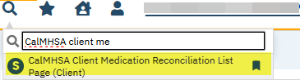
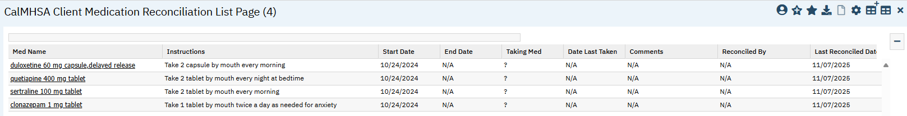
- Review medications with client to ensure that they are accurate and document medication compliance.
- Click on medication name hyperlink – this will open the CalMHSA Client Medication Reconciliation Detail Page*.
  - Document Actively Taking Medication?
  - Document Date Last Taken.
  - Enter any Medication Reconciliation Comments.
  - Click Save.

- If client reports medications which are not on this page they should be entered into SmartCare RX by navigating to Medication Management (Rx) (Client). SmartCare Rx will open in a new window.
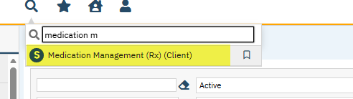
- In the new window you will see the Patient Summary for the client you had open in SmartCare. You may update or remove medications in the list.
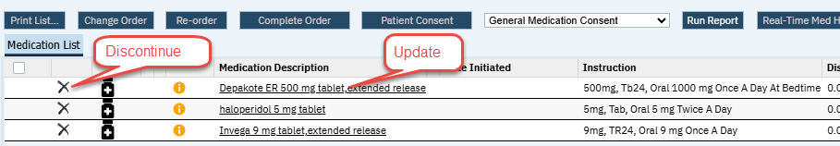
- To discontinue/remove a medication, select the “X” to the left of the medication in the Medication List.
- If there is a new medication, click the Add Medication button and enter the medication information.
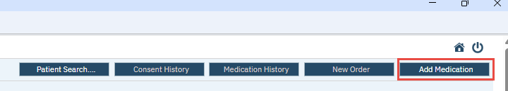
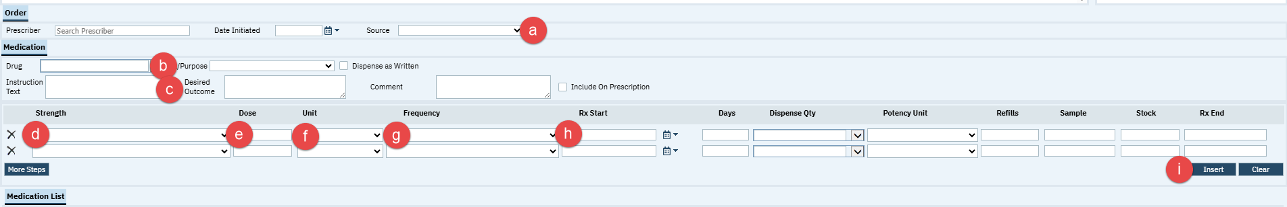
  - Source – Patient Verbal
  - Drug – Type the name of the drug and then TAB or ENTER
    - In the window that opens select the correct drug, strength and form and click Select.
  - Instruction Text/Desired Outcome – Not required.
  - Strength - The information from the selected drug will appear in the row below in the Strength field. If it isn’t correct, click the dropdown and select the correct option.
  - Dose – fill in the correct dose based on what the client takes. Example: If the client takes two 10mg tablets and the Unit is in mg then enter 20. If the Unit is in tablets enter 2.
  - Unit – Should prefill from drug selection. Adjust if needed.
  - Frequency - choose the correct frequency from the dropdown menu.
  - Rx Start – will default to today, adjust if known.
  - No other fields are relevant to home medications, click the Insert button when finished entering.
- Review the medication in the Medication List and click Save at the top right corner when ready. This will return you to the Patient Summary screen.
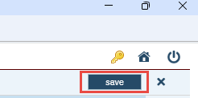
- Allergies may be entered on the Patient Summary screen. Allergies entered here will appear on all Allergies Screens and Widgets in SmartCare.
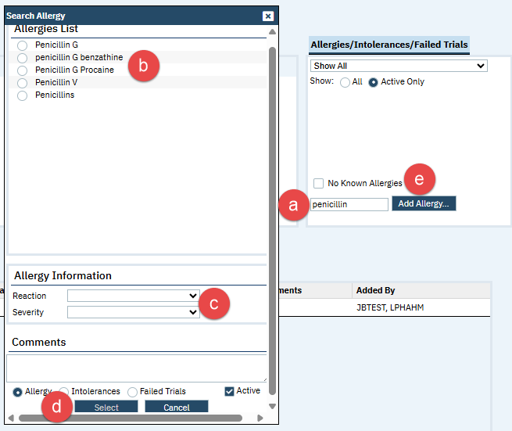
  - Type at least 3 letters into the search field and either TAB or click Add Allergy…
  - When the Search Allergy window opens locate the allergen in the list and select it.
  - Choose a Reaction and Severity and enter any Comments needed.
  - Scroll to the bottom of the window and click Select.
  - If no known allergies, check the box for No Known Allergies.
- To remove an incorrect allergy, click the X next to it.
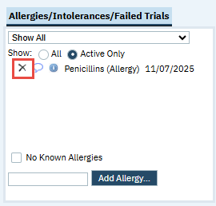
- When finished entering Medications and Allergies close the SmartCare RX window by clicking the Power icon in the top right corner.
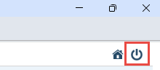

Prescriber Workflow
- Look up client in SmartCare.
- Navigate to CalMHSA Client Medication Reconciliation List Page and check to see if any medications are present.
- Review medications with client to ensure that they are accurate.
- Open CalMHSA RX and reconcile medications against what may have been entered into SmartCare RX.
  - If medications are the same and each only appears once on the CalMHSA Client Medication Reconciliation List Page, then no further action is required.
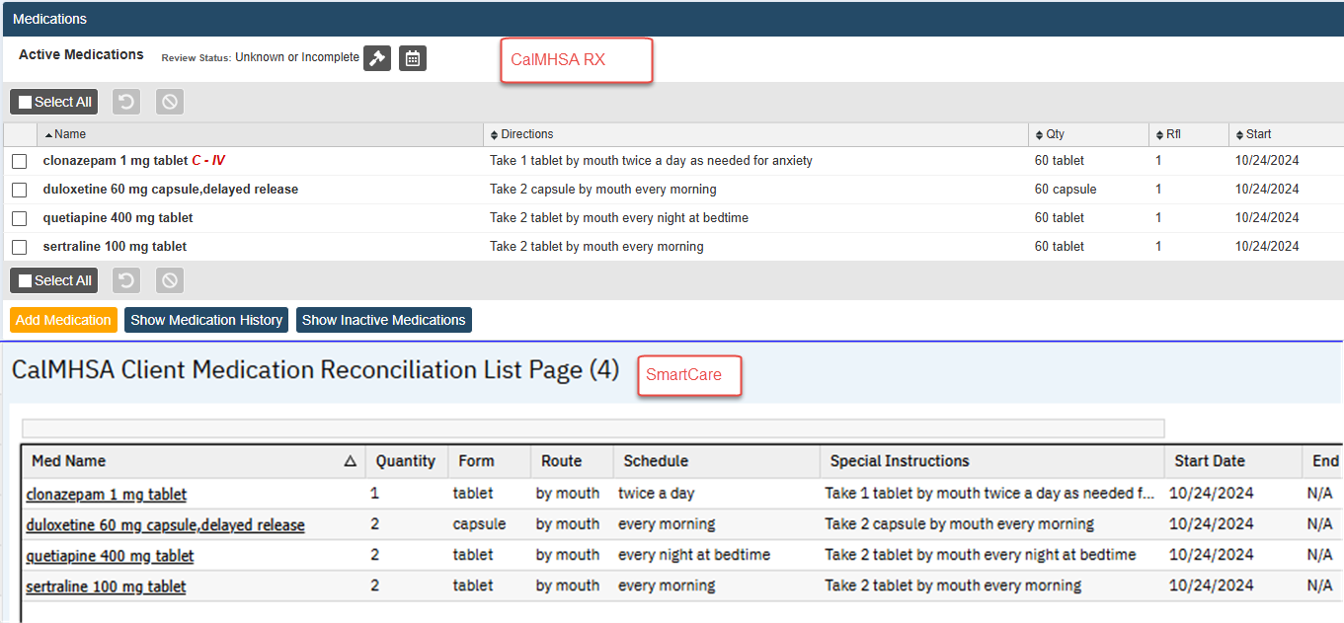
  - If any medications appear twice on the CalMHSA Client Medication Reconciliation List Page, navigate to Medication Management (Rx) (Client) to discontinue medications entered in SmartCare RX while keeping the CalMHSA RX window open. The window that opens from Medication Management (Rx) (Client) will open to the Patient Summary. Remove medications from the list which already appear in CalMHSA RX using Medication Reconciliation as the Discontinue Reason. There is no need to print the discontinuation letter, just close the windows that pop up.
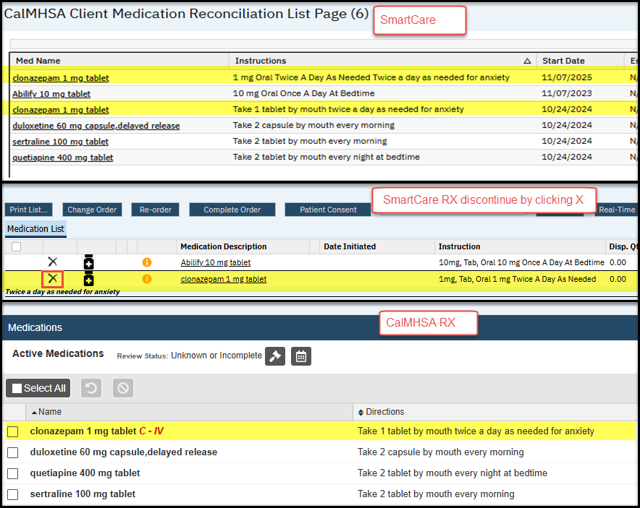
  - If there is a medication in SmartCare RX which is not in CalMHSA RX, enter it into CalMHSA RX either as a client reported medication or as a new prescription if you will be managing this medication. After entering in CalMHSA RX, discontinue it in SmartCare RX to prevent duplication.
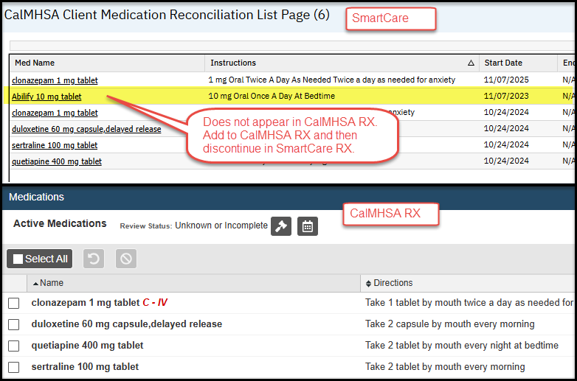
  - If client reports medications which are not on either page they should be entered into CalMHSA RX only.
- If all medications appear once on the CalMHSA Client Medication Reconciliation List Page and in CalMHSA RX then medication reconciliation is considered complete.
- To ensure that all allergies which were entered into SmartCare have also been entered into CalMHSA RX allergies may be reconciled by comparing them. Any allergies not present in CalMHSA RX should be verified with the client and then entered so that allergies will be checked when prescribing.
  - If client denies the allergy or if the allergy is not accurate, discontinue the allergy in SmartCare RX by clicking the X beside it.
  - It is important to note that the allergy lists in SmartCare RX and CalMHSA RX are completely separate but both will be pulled into the Psych/Med Note under the category “Allergies.” Please note that there can be up to a 5-minute delay or you can use the manual “Refresh” button to get updated tables. If a patient has not yet had their allergies reviewed within the e-prescribing system, then the NKDA checkbox will be not marked and grayed out. If NKDA/NKA has been marked, then the box will gray out depending on the source.
  - If the same allergen (or NKDA/NKA) has been listed in multiple systems, then these will be listed as duplicates in this report, and there is no mechanism to capture any discrepancies.
  - The “Do Not Include in PDF” functionality can be utilized.
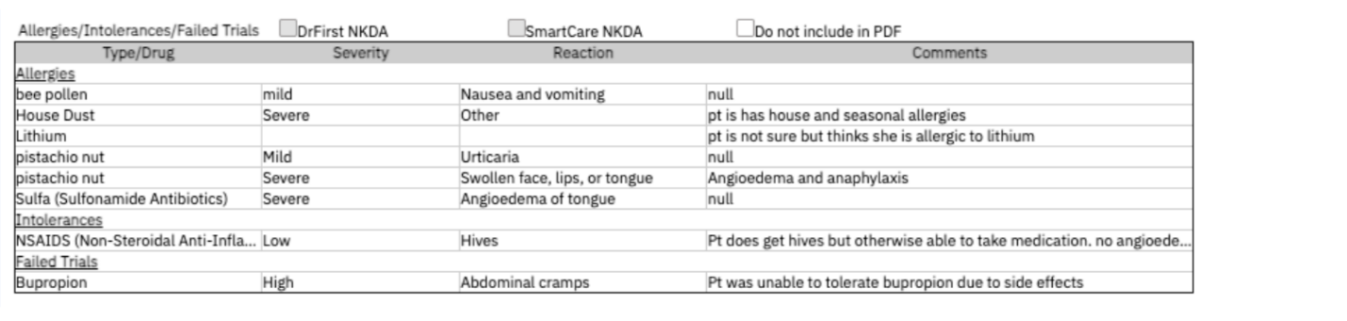

Additional Workflow Resources

Home Medication Guide for Prescribers
- Navigate to CalMHSA Client Medication Reconciliation List Page: How to Complete a Medication Reconciliation
- Navigating to SmartCare RX Medication Entry Screen and Looking up Client: First Way: Rx Screen to Patient Search
- Deleting Home Medications in SmartCare RX: How to Discontinue a Medication

Home Medication Guide for Non-Prescribers
- Navigate to CalMHSA Client Medication Reconciliation List Page: How to Complete a Medication Reconciliation
- Navigating to SmartCare RX Medication Entry Screen and Looking up Client: First Way: Rx Screen to Patient Search
- Entering Home Medications in SmartCare RX: How to Add Medications Prescribed Elsewhere
- Entering Client Reported Allergies in SmartCare:
  - How to Add an Allergy, Intolerance, or Failed Trial
  - How to Update an Allergy, Intolerance, or Failed Trial
  - How to Delete an Allergy, Intolerance, or Failed Trial

